**Designer**



[](https://github.com/sujivan96)

[](https://wa.link/szps2u)

**Jeshinthan Krisen**

**EDUCATION**

**BICT(Hons) in Information and**

**Communication Technology**

Faculty of Technological Studies, University of Vavuniya, Sri Lanka

-2018-2021

**BIO SYSTEM TECHNOLOGY**

M/Oddusuddan Maha Vidyalaya

2014-2015

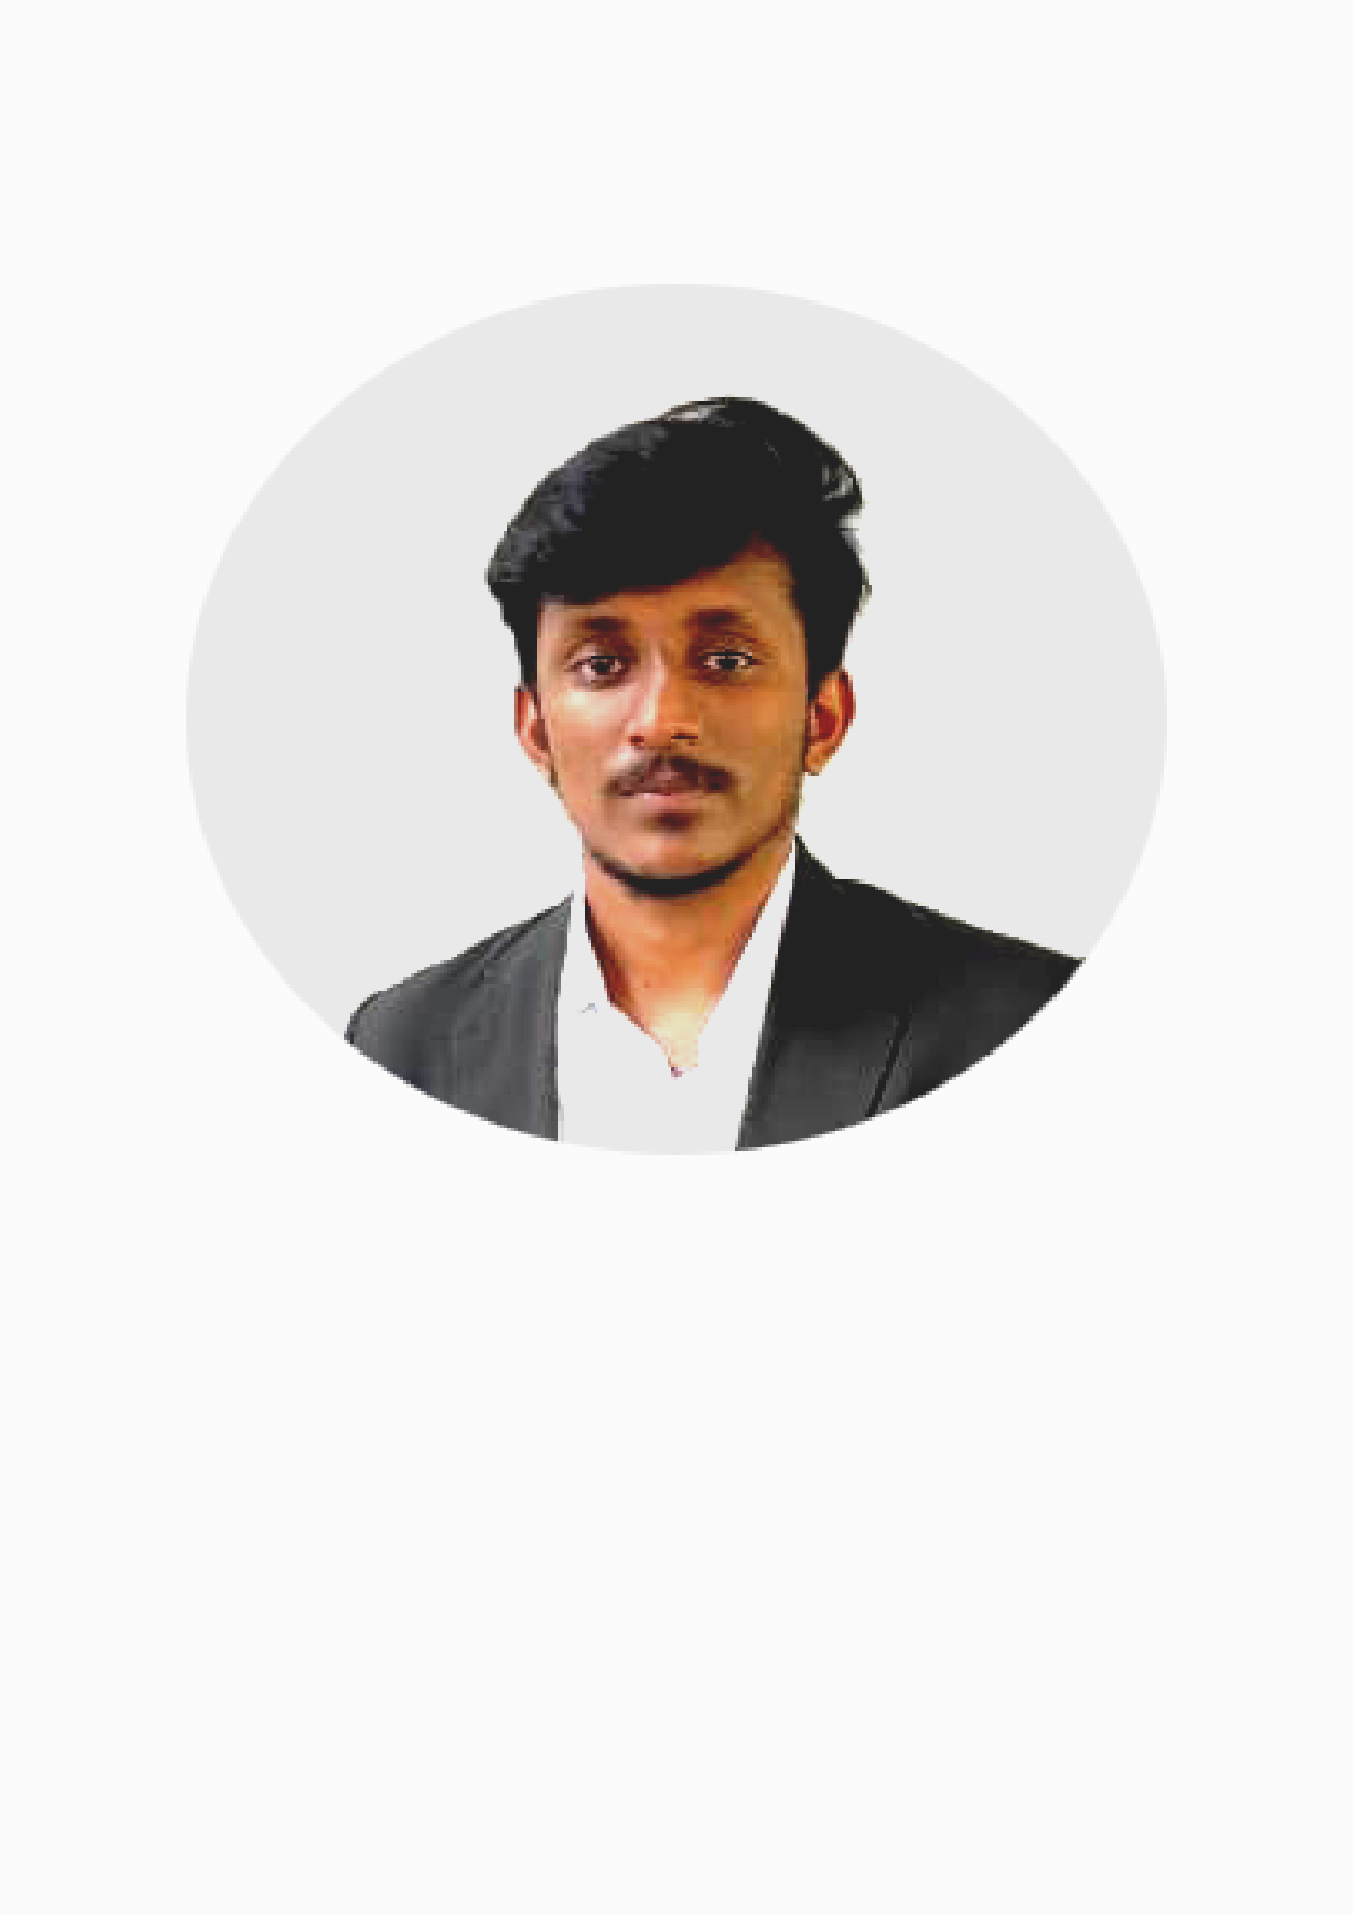



**Profile**

Highly motivated BICT (hons) graduate with a strong foundation in Graphical Designer. Proficient in a variety of platforms Graphical Tools , with an innate ability to learn and master new technologies.

**Designer**

WORK EXPERIENCE

Photo Editing-studio

Jersy &Logo design

**PROJECTS**

**Mobile App UI&UX development**

**Tour_lanka UI&UX desing app**

**LMS Project**

This project developed with use of WordPress.

## E-commerce website

## This project developed with use of WordPress.







**Phone**

**+94 771 473 324**

**E-Mail**

[**jjeshinthan@gmail.com**](mailto:jjeshinthan@gmail.com)

**Address**

**Oddusuddan ,Mullaitivu, Sri Lanka**

**SKILLS**

**Programming Languages** (C. C++, C#/.Net, JAVA, PHP, ASSEMBLY, PYTHON)

**Web Design and Development (Frontend and backend)**

**Technical analysis**

**Teamwork**

**Database Management**

Page 1 of 2

**WordPress**

**Node Js**

**React Js**

**Spring Boot**

**FRAMEWORKS &TOOLS**

**LANGUAGES**

**English**

Professional working proficiency

**CERTIFICATES**

Certificate of Spoken English

Certificate of Course Completion Introduction to Cybersecurity - **Cisco Networking Academy**

Certificate of Course Completion Cybersecurity Essentials - **Cisco Networking Academy**

Certificate of Course Completion PCAP: Programming Essentials in Python - **Cisco Networking Academy**

Certificate of Course Completion Introduction to Packet Tracer - **Cisco Networking Academy**

Certificate of Course Completion NDG Linux Unhatched **- Cisco Networking Academy**

**Certificates of Sports – District &zone**

Certificate of Spoken English

**ORGANIZATIONS**

IEEE - Member

Eswaran sports club member

Oddusuddan division youth board member(2019-2020)

**INTERESTS**

Music | Reading | Travel | Photography | Volunteer Work/Community Involvement | Editing

**Tamil**

Native or bilingual proficiency

**NON-RELATIVE REFERENCES**

**Mr.D.S.S.S.Suthakaran**

Dean, Faculty of Technological Studies, University of Vavuniya

Phone - +94772316644

Email- [suthaharan@vau.jfn.ac.lk](mailto:suthaharan@vau.jfn.ac.lk)

**Mr.V.Senthooran**

Head of department,

Department of ICT,

Faculty of Technological Studies, University of Vavuniya.

Phone - +94772101863

Email- [vijaysenthoor@gmail.com](mailto:vijaysenthoor@gmail.com)

Page 2 of 2